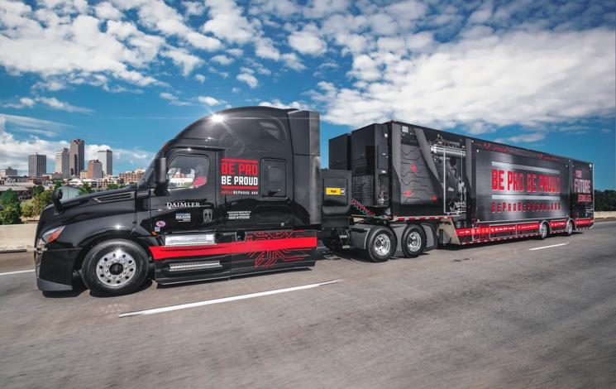

FOR IMMEDIATE RELEASE

Media Contact:

(Insert Name)
(Insert Title)
(Insert Organization)
(Insert Email)
(Insert Phone)

MEDIA ALERT: Be Pro Be Proud brings Mobile Workshop to (location/organization)

(Insert Location) (Insert Date) – The Be Pro Be Proud Mobile Workshop will visit (name of location/organization), (Day), (Date) beginning at 9:00 am – 3:00 pm. The Arkansas State Chamber and its public and private partners launched Be Pro Be Proud in 2016 to address an expanding skills gap in professional trades across the state. Arkansas’s future will depend on changing the perception of these career options and efforts highlighting the many opportunities available within these sectors.

“Since launching Be Pro Be Proud in 2016, Arkansas has been leading the nation in supporting skilled trade and professions allowing us to better compete in the global marketplace,” said the Hon. Asa Hutchinson, Governor of Arkansas. “I encourage everyone to be a part of the Be Pro Be Proud movement. It shows that we are serious about educating parents and young people about these career paths that are essential to our state’s economic growth.”

The 12 in-demand professions that continue to be represented include truck driver; diesel tech; locomotive engineer; welder; machinist; computer numerical control (CNC) operator; tool and die maker; computer programmer; computer-aided design and computer-aided manufacturing (CAD/CAM) drafter; heating, ventilation, air conditioning and refrigeration (HVACR) tech; plumber; electrician and carpenter.

For more information visit, please visit BeProBeProud.org or call 501-372-2222.

